MARKETS | PAKISTAN STOCK EXCHANGE
Does Momentum Work in Pakistan Stock Market?
A decade of KSE-100 data shows past winners do outperform — but the signal is messier than the headline number suggests.
By Muhammad Moeed | April 2025
KSE-100 Factor Analysis | 2015–2025 | Real PSX Price Data

The question sounds almost too simple to be worth asking: if a stock has been going up for the past year, does it tend to keep going up? That is momentum, and it is one of the most studied phenomena in all of quantitative finance.
Using ten years of real PSX price data from 2015 to 2025, the analysis ranks every KSE-100 stock by its past 12-month return, sorts them into five groups, and asks whether the top group (the “winners”) consistently outperforms the bottom group (the “losers”) going forward. The answer is yes — but with important caveats that make the story more interesting than a simple yes or no.
Past winners on the KSE-100 compounded at 30% per year. Past losers managed only 16.6%. The gap is hard to ignore.
The Setup: How Momentum Is Actually Measured
Before getting to the results, it’s worth being precise about what “momentum” means here, because the word gets used loosely. The standard academic definition, which this analysis follows, is the 12-1 signal: you rank stocks by their total return over the past 12 months, skipping the most recent month. That last part — skipping the last month — is deliberate. The very short-term has a known reversal effect where stocks that went up last month tend to pull back slightly, and including it would contaminate the signal.
Every month, stocks are sorted into quintiles. Q1 holds the worst 20% of performers over the past year. Q5 holds the best 20%. The question is whether buying Q5 and simply avoiding Q1 makes money over time.
The winner-loser spread is the cleanest expression of the idea: compare the returns of Q5 against Q1 and see how large the gap is. If momentum is real, this spread should be consistently positive. If it’s noise, the spread should hover around zero.
Ten Years of Winners vs. Losers
The chart below is the most direct way to visualise the result. Three portfolios are tracked from 2016 to 2026, each rebalanced monthly: momentum winners (Q5 in blue), momentum losers (Q1 in pink), and an equal-weight market benchmark (yellow dashes).
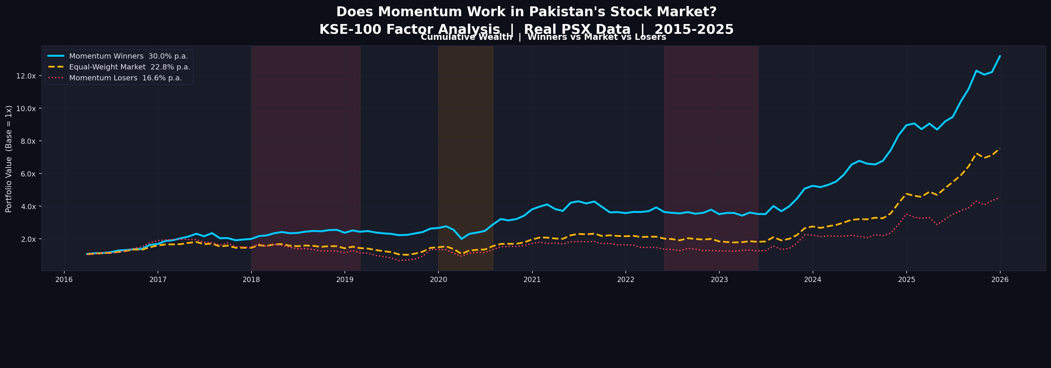
Fig. 1 | Cumulative portfolio value starting at 1x. Shaded regions mark bear market periods. Winner portfolio compounds at 30% p.a. vs. 16.6% for losers.
Over ten years, one rupee invested in the winner portfolio grew to roughly 12x. The same rupee in the loser portfolio grew to about 4.7x. The equal-weight market landed around 7x. The visual separation is stark, particularly from 2022 onwards where the winner portfolio breaks away decisively.
One thing the chart makes clear is that this is not a smooth ride. The shaded bear market periods — particularly 2020 and the 2022–23 KSE correction — hit all three portfolios hard. The winner portfolio is not immune to drawdowns. What it does is recover faster and compound more aggressively in bull periods.
The Quintile Picture: Where It Gets Interesting
If momentum is working cleanly, you would expect a monotonic staircase: Q1 earns the least, Q2 a bit more, Q3 more, Q4 more, Q5 the most. A perfect gradient from worst to best.
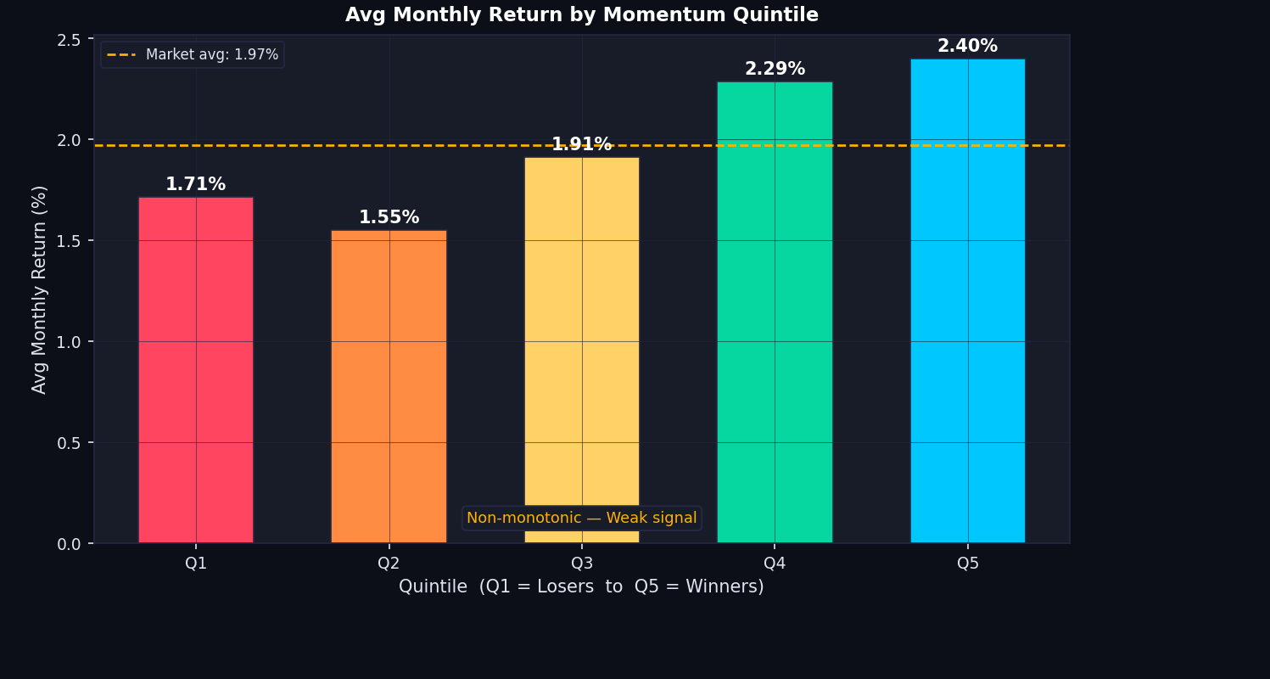
Fig. 2 | Average monthly return by momentum quintile. Market average is 1.97%. Note the non-monotonic dip at Q3.
The PSX data gives you most of that staircase, but not all of it. Q1 (losers) earns 1.71% per month. Q4 earns 2.29%. Q5 (winners) earns 2.40%. The extremes behave as theory predicts. The problem is Q3, which dips below Q2. The middle quintiles are not stairstepping neatly.
This non-monotonicity matters because clean factor investing generally wants the gradient to be consistent across all five buckets, not just the two extremes. What this tells you is that the real trade on PSX is specifically the Q5 vs Q1 pair — the tails. The middle of the distribution is noisy, which is not unusual for emerging markets with thinner liquidity, but a practitioner would want to know this before building a strategy.
Beating the Market on a Risk-Adjusted Basis
Raw returns can be misleading. A portfolio that earns 30% per year might simply be doing so by being riskier than the market — taking on more volatile stocks, holding more concentrated positions. The standard way to check this is CAPM, the Capital Asset Pricing Model.
CAPM says the expected return of any portfolio equals the risk-free rate plus beta times the market risk premium. Beta measures how much your portfolio moves relative to the market. A beta of 1 means you move one-for-one. The interesting number is alpha: the return left over after accounting for your beta exposure. Alpha is what you actually earned beyond what your risk level entitles you to.
The momentum winner portfolio has a beta of 0.805 — it is actually slightly less volatile than the market. And its CAPM alpha is 10.01% per year. A 10% annual alpha above what a portfolio with beta 0.8 should earn is exactly what you want to see from a genuine factor strategy.
Alpha Over Time: A More Honest Picture
A single alpha number for the full decade hides a lot of variation. The rolling 12-month alpha chart below shows how that 10% average was actually distributed across time.
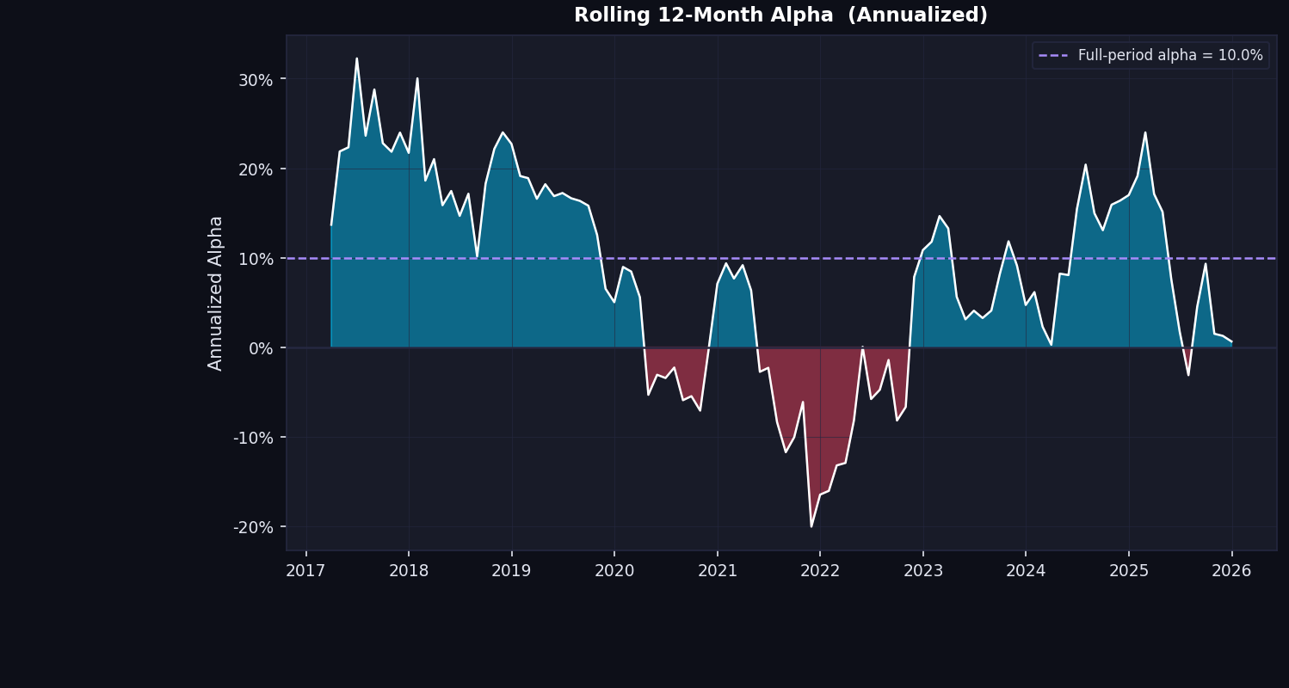
Fig. 3 | Rolling 12-month annualised alpha. Dashed blue line marks the full-period average of 10%. Red shading indicates periods of negative alpha.
The strategy spends a meaningful amount of time with negative alpha — particularly around 2020 through mid-2022. These are the COVID crash and the subsequent KSE bear market. Momentum strategies have a well-documented vulnerability to sharp reversals: when markets turn suddenly, last year’s winners become this year’s victims. The PSX data confirms this pattern.
From 2023 onwards, the alpha recovers significantly and spends most of its time well above the 10% average line. The practical takeaway is that momentum works best when markets are trending, and tends to suffer most during violent direction changes.
The Winner-Loser Spread: Where the Statistics Get Honest
The return spread between Q5 and Q1 is the most direct test of whether the momentum premium exists. The annualised gap is 5.3%, which sounds respectable. But the distribution of monthly returns tells a more complicated story.
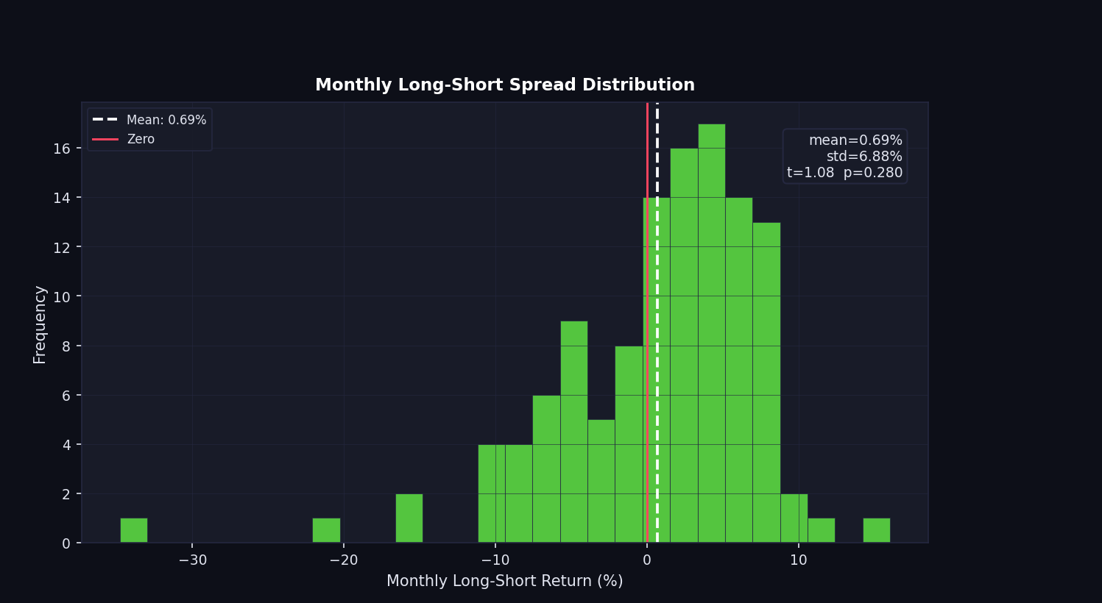
Fig. 4 | Distribution of monthly Q5 minus Q1 return spreads. Mean of 0.69%, std of 6.88%. Positive on average but highly variable.
The average monthly spread is 0.69%, but the standard deviation is 6.88%. That is a huge amount of noise relative to the signal. The t-statistic is 1.08, giving a p-value of 0.280. In plain terms: this result would occur by chance roughly 28% of the time even if there were no real momentum premium at all. That is well above the conventional 5% significance threshold.
This is the honest part of the analysis. The momentum winner portfolio looks great in isolation — 30% per year, positive alpha, low beta. But the actual edge over the loser portfolio, once you strip out market exposure and look at the pure Q5 minus Q1 spread, is statistically indistinguishable from noise.
The winner portfolio looks excellent. The Q5 minus Q1 spread does not clear the statistical bar. Both things are true at the same time.
The Numbers in Full
The performance summary below consolidates the key metrics across the three portfolios. The Sharpe ratio — return per unit of volatility — is 0.80 for winners versus 0.51 for the market. The win rate is 68.6% for winners versus 61% for the market. The maximum drawdown for the winner portfolio is -27.8%, much better than the market’s -43.6%.
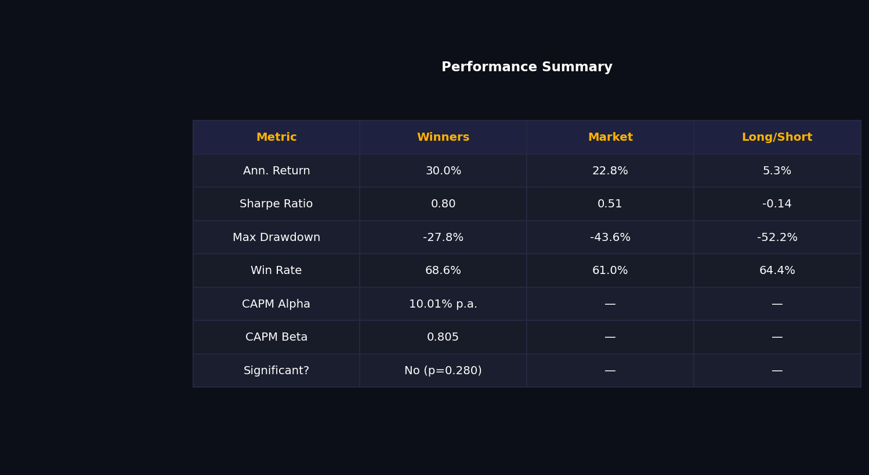
Fig. 5 | Performance summary table. CAPM alpha of 10% p.a. with beta of 0.805. Winner-loser spread p-value = 0.280.
The Q5 minus Q1 spread has a Sharpe ratio of -0.14 and a simulated max drawdown of -52.2% if you were somehow able to capture it in isolation. That number is largely theoretical for PSX investors — it reflects a construct that assumes you can profit from the losers falling, which you cannot here. What it does tell you is that the spread itself is extremely volatile and unreliable on its own.
When Does It Work? A Look at Market Regimes
Perhaps the most practically useful part of the analysis is what happens when you split the sample by market regime: bull markets, bear markets, and sideways periods.
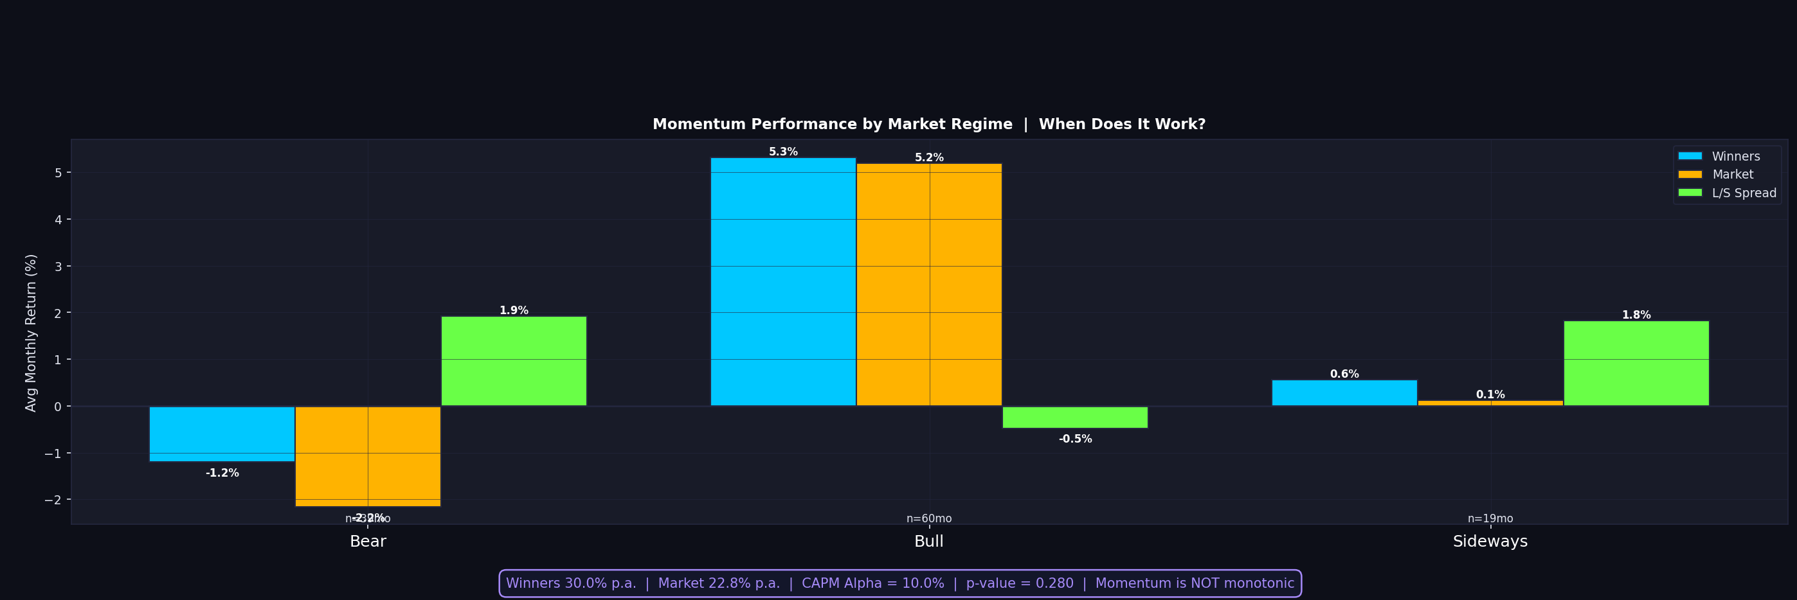
Fig. 6 | Average monthly returns by market regime. Momentum shows a positive spread in bear markets and is marginal elsewhere.
In bull markets (60 months of the sample), both winner and loser quintiles run together — a rising tide lifts all boats, and the spread between them is actually slightly negative. In bear markets (22 months), losers fall harder than winners, generating a 1.9% positive spread. In sideways markets the spread is minimal at 1.8%.
This is somewhat counterintuitive. You might expect momentum to shine in bull markets. What the PSX data shows instead is that in bull markets the spread narrows, while in bear markets the losers fall faster. The winner portfolio still loses money in downturns — just less than the losers.

So Does Momentum Work in Pakistan?
The short answer is: partially, and conditionally. The momentum winner portfolio on the KSE-100 compounded at 30% per year over the past decade, produced a CAPM alpha of 10% annualised, and did so with less market risk (beta 0.8) than a passive index allocation. By those measures, yes, momentum works.
But the winner-loser spread — the gap in returns between the top and bottom quintiles — is not statistically significant. The 5.3% annual gap has too much noise around it to rule out luck. The quintile returns are not monotonic. The spread has a Sharpe of -0.14 as a standalone construct. These are real limitations.
The more nuanced conclusion is that past performance does contain information in Pakistan’s market — enough to give the top quintile a consistent edge over the index and over the bottom quintile. But whether that edge is large enough and reliable enough to build a trading strategy around, net of transaction costs and momentum crash risk, is a different question. The data says: maybe, if you are careful about when you run it.
For a market that is under-researched quantitatively and still dominated by retail participation and periodic macro shocks, finding even a messy version of this signal is meaningful. In more efficient markets, a 10% alpha would be arbitraged away almost immediately. That it persists here — however noisily — says something about the information environment on the KSE.
Finding even a messy version of this signal in an under-researched market like Pakistan is meaningful in itself.

Methodology note: Analysis uses real KSE-100 price data from 2015 to 2025. Momentum signal is 12-1 monthly return ranking. Portfolios are equal-weighted within quintiles and rebalanced monthly. CAPM estimation uses the KSE-100 equal-weight index as the market proxy. Transaction costs are not modelled. All returns are price returns, dividends excluded.

